Simulating the Butterfly Effect of a Small Code Error (Part 2)

Christoffer Hansen
Grand Canyon University
CST-305: Principles of Modeling and Simulation Lecture & Lab
Instructor: Ricardo Citro
December 7, 2025

1. Responsibilities and Completed Tasks
This project was completed independently, with all modeling, code development, mathematical analysis,
and documentation performed by the author. The following major responsibilities were fulfilled:
• Designed a software-oriented conceptual model demonstrating the butterfly effect in code systems.
• Developed a complete Python data pipeline including raw-data generation, correct preprocessing,
buggy preprocessing, statistical analysis, metric generation, and visualization.
• Created a Code Butterfly Severity (CBS) metric for quantifying deviation caused by a small defect.
• Conducted comparative analysis between correct and erroneous system behavior.
• Produced this detailed technical report meeting CST‑305 documentation standards.
2. System Performance Context Description
In modern computing systems, performance and reliability depend heavily on the repeated transformation,
scaling, and filtering of raw instrumentation data. Cloud monitoring platforms, anomaly detection engines,
and distributed control systems typically rely on multi-stage pipelines that standardize, normalize, and
interpret incoming measurements. Even a minor error in a preprocessing routine—such as an incorrect scaling
factor—can propagate into severe misinterpretation of system health, causing false alarms, suppressed alerts,
or incorrect automated responses. This project models such sensitivity by demonstrating how a tiny preprocessing
bug can drastically alter downstream analytics, similar to the unpredictable divergence of trajectories in
chaotic dynamical systems such as the Lorenz attractor.
3. Specific Problem Solved
The core problem explored in Part 2 is determining how a micro-level programming error can amplify into
macro-level distortions in a software system's outputs. The objective is to show how a nearly invisible defect
in normalization—specifically using σ² instead of σ—produces major discrepancies in statistical measurements
such as variance and derived risk scores. By running both the correct and buggy pipelines side-by-side, the project
demonstrates the sensitivity of software workflows to subtle component faults and quantifies the resulting
behavioral divergence.
4. Mathematical Approach
The pipeline models three main transformations:
1. Raw Data Generation:
A vector x is drawn from a normal distribution x ~ N(50, 10).
2. Correct Normalization:
z_i = (x_i - μ) / σ
3. Buggy Normalization:
ẑ_i = (x_i - μ) / σ²
4. Statistical Outputs:
• Mean: m = mean(z), m̃ = mean(ẑ)
• Variance: v = var(z), ṽ = var(ẑ)
• Risk Score (logistic): r = 1/(1 + e^(−v)), r̃ = 1/(1 + e^(−ṽ))
5. Code Butterfly Severity (CBS):
• Absolute deviation:
CBS_abs = || y_correct − y_buggy ||₂
• Relative deviation:
CBS_rel = CBS_abs / (||y_correct||₂ + ε)
These mathematical tools create a discrete analogue to chaotic divergence, allowing software behavior to be
treated as a sensitivity experiment similar to differential-equation‑based models.
5. Implementation Approach (Algorithm and Flowchart)
The implementation consists of nine structured steps:
1. Initialize environment and set reproducible random seed.
2. Generate raw data values from a normal distribution.
3. Apply Stage‑1 normalization using both correct and buggy formulas.
4. Compute statistical summaries (mean, variance, risk).
5. Package outputs into structured dictionaries.
6. Compute the CBS metric comparing correct and buggy outputs.
7. Print system execution phases to the console.
8. Render histogram comparisons and metric visualizations.
9. Display results to the user.
Flowchart:
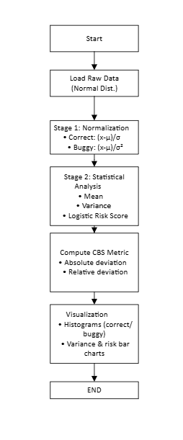
6. Screenshots of Program Execution
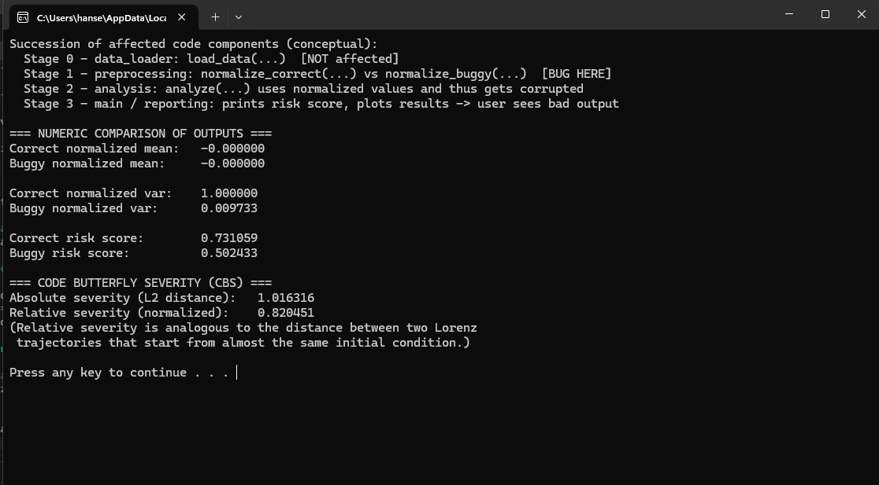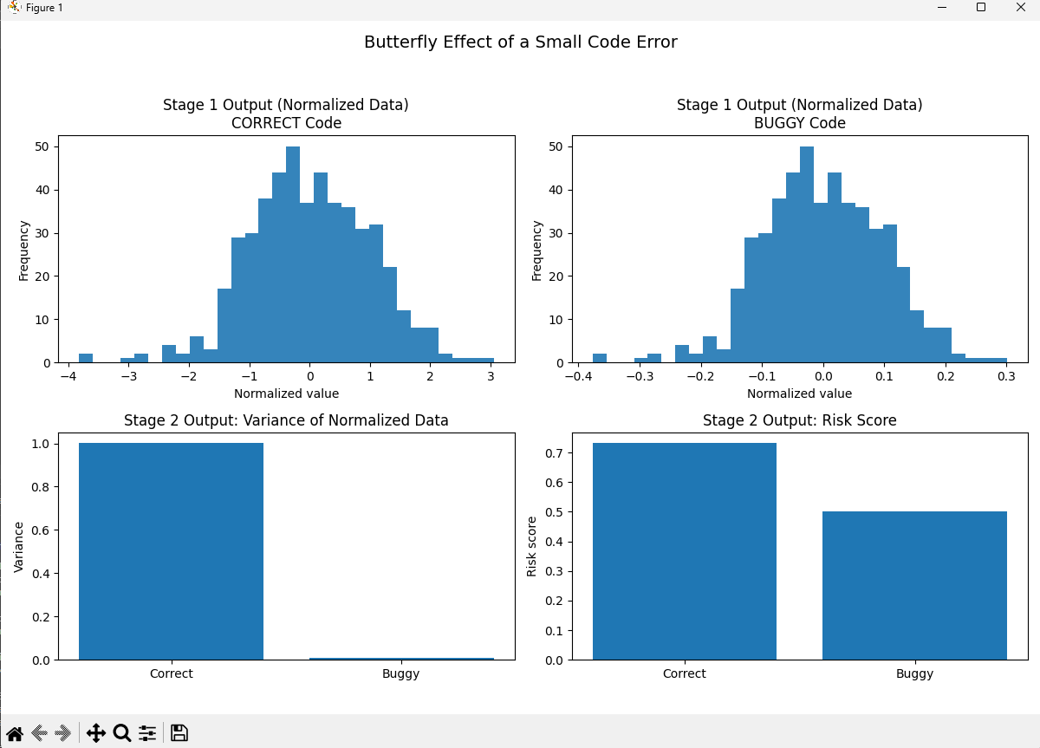7. Results and Interpretation
The comparative visualizations reveal pronounced divergence between correct and buggy system states.
The correct pipeline produces normalized data centered at zero with unit variance. The buggy pipeline,
however, compresses the distribution significantly due to division by σ², yielding a much lower variance
and misleadingly low risk score. This clearly demonstrates how a tiny mathematical slip in code can distort
system health analytics, misrepresent statistical properties, and misguide decision-making algorithms.

8. References
Lorenz, E. N. (1963). Deterministic nonperiodic flow. Journal of Atmospheric Sciences.
Strogatz, S. H. (2015). Nonlinear Dynamics and Chaos.
Sparrow, C. (1982). The Lorenz Equations: Bifurcations, Chaos, and Strange Attractors.
ZyBooks. (2025). CST-305: Differential Equations and Modeling.

